German Vista with Oberammergau and

the Passion Play
8 Day Tour from Berlin to Munich
Aug. 8-16 2022
$4200 Per Person – Price is an estimate and is subject to change. Final price will be published when air can be purchased 1 year in advance.
Price includes tour, Passion Play, roundtrip air from Nashville (other cities are available upon request), transfers, Breakfast Buffet every day and 3 three-course meals

Vacation Overview
When you think of a vacation to Germany, what comes to mind? Perhaps it’s visiting fairytale castles and medieval towns. Perhaps it’s seeing the Bavarian Alps and beautiful countryside. Perhaps it’s savoring German food and beer. If so, all of this and more are included on this marvelous Germany tour from Berlin to Munich.
Sightseeing in each city includes the must-see sights. In Berlin, you’ll visit Kaiser Wilhelm Memorial Church, badly damaged during the war and today a symbol of reconciliation. During your walking tour in Dresden, visit the courtyard of Zwinger Palace, one of Germany’s best-known baroque buildings. In Munich, visit the lively Marienplatz. Here, observe the famous glockenspiel, which re-creates a 16th-century wedding. You’ll also visit Weimar, where you’ll enjoy a pleasant walk through the town.
Highlights of this Germany tour are a drive along the Romantic Road past small villages to visit Neuschwanstein Castle, King Ludwig II’s fairytale castle nestled in the beautiful Bavarian Alps. You’ll even stay in a charming hotel beautifully located between Neuschwanstein Castle and Hohenschwangau Castle, the family home of King Ludwig. Another unique experience, included on this Germany tour, is an overnight in medieval Rothenburg with its ramparts and towers, cobblestone lanes, and 16th-century houses. In the charming village of Oberammergau, see the world-famous Passion Play, performed every 10 years by Oberammergau residents. With the majestic alpine scenery in the background, it’s a once-in-a-lifetime experience. Of course, no vacation to Germany is complete without experiencing a lively Biergarten, a farewell dinner, is included, at one in Munich.
Throughout this Germany tour, you’ll be accompanied by a Tour Director who knows the ins and outs of Germany—its history, secrets, culture, and language. All you have to do is sit back, relax, and enjoy this fantastic Germany tour!
This vacation, which includes tickets for the world-famous Oberammergau Passion Play, requires an additional deposit of $350 per person in June 2019.
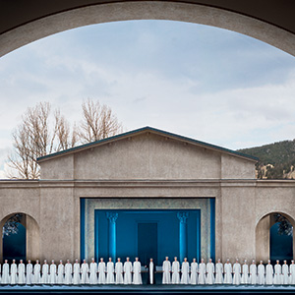
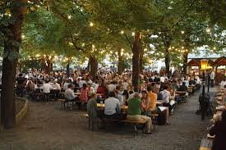
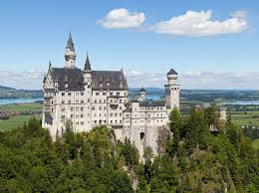

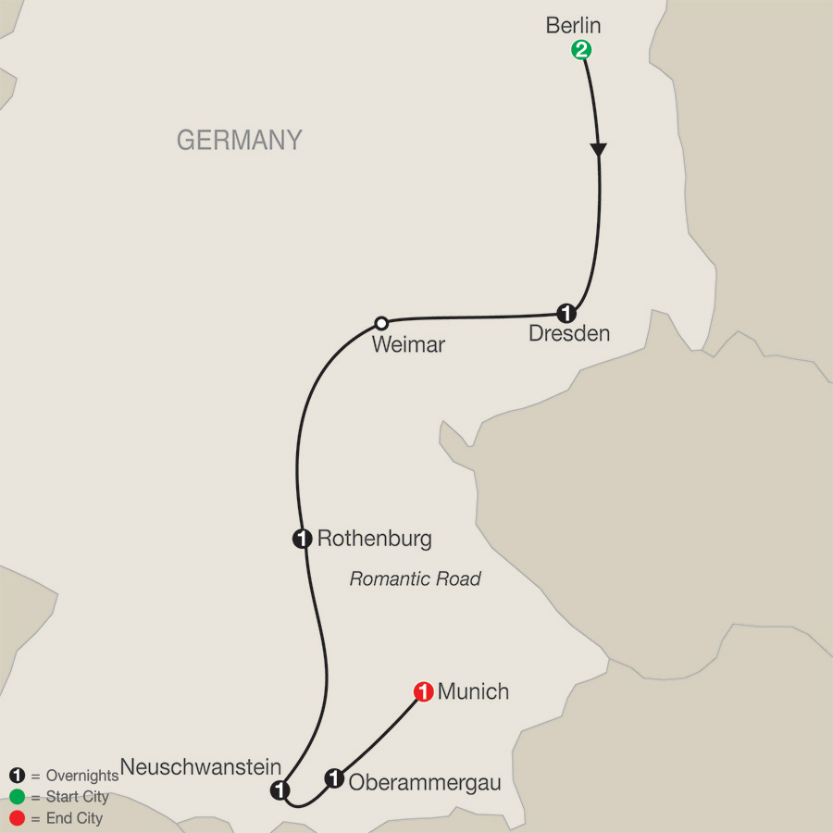

Itinerary

Day 1 ARRIVE IN BERLIN, GERMANY
Time to rest or to start exploring the German capital. At 6 pm, meet your Tour Director and traveling companions for a welcome dinner at your hotel.
Dinner

Day 2 BERLIN
Sightseeing with a Local Guide in the once-divided metropolis includes the elegant Ku’damm, the restored Reichstag, Charlottenburg Palace, a picture stop at monumental Brandenburg Gate and the Holocaust Memorial, and the 210-foot Victory Column in the vast Tiergarten park. Visit the KAISER WILHELM MEMORIAL CHURCH with its bomb-damaged tower, drive along Unter den Linden boulevard, and pass the State Opera House and Checkpoint Charlie.
Breakfast

Day 3 BERLIN–DRESDEN
Arrive in Dresden, former capital of Saxony. Badly damaged by Allied bombing in February 1945, the city has since been restored to its baroque splendor. During your guided walking tour, visit the Zwinger Palace COURTYARD to admire its impressive architecture; the magnificent baroque Semper Opera, originally built in 1841, once destroyed by fire, then destroyed by bombing, and finally restored in 1985; and the newly rebuilt Frauenkirche.
Breakfast

Day 4 DRESDEN–WEIMAR–ROTHENBURG
In Weimar, follow your Tour Director on a pleasant walk to the pretty MARKET SQUARE with its Renaissance houses and the Town Hall. Highlight is an overnight stay in medieval Rothenburg with its ramparts and towers, cobblestone lanes, and 16th-century houses. Hear how the town survived the Thirty Years’ War, and shop for Christmas ornaments.
Breakfast

Day 5 ROTHENBURG–NEUSCHWANSTEIN
Drive along the scenic Romantic Road past small villages and towards the Bavarian Alps, where two of Bavaria’s most famous castles are situated. Stay overnight in a charming hotel beautifully located beneath Hohenschwangau Castle, where King Ludwig spent much of his youth, and NEUSCHWANSTEIN CASTLE, which you will visit with a Local Guide. This castle became the most famous of all and was inspiration for Walt Disney’s Sleeping Beauty Castle.
Breakfast

Day 6 NEUSCHWANSTEIN–OBERAMMERGAU
Arrive in picturesque Oberammergau. The afternoon and evening are dedicated to the world-famous PASSION PLAY, held every 10 years and performed by the people of Oberammergau.
Breakfast
Dinner

Day 7 OBERAMMERGAU–MUNICH
Drive to Munich where your orientation features a visit to MARIENPLATZ with its Old and New Town Halls and the gothic Frauenkirche. In the evening, a farewell dinner at a lively Biergarten is the best way to celebrate the success of your German vacation.
Breakfast
Dinner

Day 8 MUNICH
Your vacation ends with breakfast this morning.
Breakfast

Vacation Highlights
BERLIN
Welcome dinner; guided sightseeing, visit Kaiser Wilhelm Memorial Church, picture stop at Brandenburg Gate & Holocaust Memorial
DRESDEN
Guided sightseeing, visit the Courtyard of Zwinger Palace
WEIMAR
Orientation
ROTHENBURG
Stay overnight in the medieval town
NEUSCHWANSTEIN
Guided visit of King Ludwig’s castle
OBERAMMERGAU
Passion Play
MUNICH
Orientation drive, visit Marienplatz; farewell dinner in the beer garden of a local restaurant
Headsets throughout the tour.

Meals
Full buffet breakfast daily; 3 three-course dinners with wine, including a welcome dinner and a special farewell dinner in Munich.

